**ANALYTICAL STUDY – 2**

**LAYS**

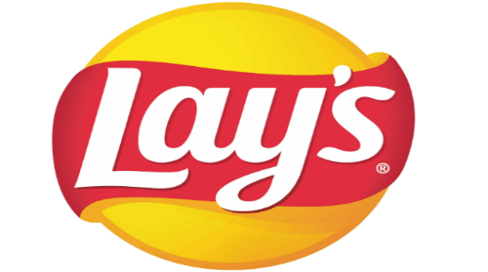

**Owner : PepsiCo**

**CEO : Steven Williams**

**FOUNDED IN : 1940**

**PRODUCT TYPE : Potato chips**

**MARKETING STRATEGY**

1. **Target and Position Strategy:** Lays' marketing strategy focuses on identifying regions where the brand is most popular and strategically establishing production units in those areas. By [analysing consumer preferences](https://startuptalky.com/understanding-repeat-purchases-online/) and market demand, Lays ensures its products are readily available and tailored to the tastes of the local population.
2. **Celebrities Endorsement:** The brand of chips is promoted by several celebrities, which makes people purchase them more often. (**Ranbir Kapoor, Damon Vincent, Zach & Tee, and Mahendra Singh Dhoni)**
3. **Affordability**: The prices of these chips are very affordable. They are accessible to everyone in society. (5Rs,10Rs, 20Rs etc.)
4. **Diverse flavours:** There are a variety of flavours available, so every person can find something that suits their taste buds**.**( [**Classic Salted, American Style Cream & Onion, Spanish Tomato Tango,** and**India’s Magic Masala**](https://www.bing.com/ck/a?!&&p=ffcd8f58cfe2e412JmltdHM9MTY5MzQ2NzkzNw&ptn=3&hsh=3&fclid=601ebbe0-47d2-11ee-abd4-ca13cfd85b63&u=a1aHR0cHM6Ly93d3cubGF5cy5jb20vcHJvZHVjdHM&ntb=1&bc=1&key=psc-underside&usparams=cvid%3a51D%7cBingProdUnAuthenticatedUsers%7cD264A2366C9974EC1B831B9A27C0495799CE8A44BE8461861A7557F9F0296A84%5ertone%3aBalanced)**,** Sunkissed tomato)
5. **Advertising:** Lay’s advertises its great taste through great advertising. Consumers become interested in trying it.
6. **Partnerships and Sponsorships:** Collaborating with sports events, movies, or other brands can help Lays expand their reach and visibility. For instance, they might sponsor a major sports event and create limited-edition packaging to tie in with the event.